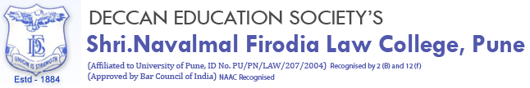
Report on Students Participation in
COEP’s ZEST 2023
ZEST’23, is the annual and national level sporting extravaganza conducted by the College of Engineering, Pune (COEP). ZEST was scheduled from 11th to 13th of February 2023 at COEP ground, Near Sancheti hospital, Pune.
Students of D.E.S. Law College participated in most sports including Box Cricket, Football, Basketball, Handball, Chess, Carrom, Table Tennis and Badminton. Moreover demonstrated an outstanding performance in the following sports:
1. ATHLETICS:
- Boys 200m:
- Anirudha Lokhande- Gold
- Kunal Jagrut – Silver

- Girls 1500m:
  - Prabha Goswami – Silver

- Boys 800m:
  - Anirudha Lokhande – Silver

- Boys 4×100m relay( Silver):
  - Kunal Jagrut
  - Bhushan Jadhav
  - Jay Kshirsagar
  - Anirudha Lokhande

- Girls 4×100m relay( Bronze):
  - Prabha Goswami
  - Aditi Shah
  - Akshata Yadav
  - Shreya Bodhe
- Girls 4×400m relay (Silver):
  - Prabha Goswami
  - Aditi Shah
  - Akshata Yadav
  - Shreya Bodhe.
2. CARROM:
- Boys Singles:
  - Bhushan Jadhav (Finalist)

- Girls Singles:
  - Prabha Goswami (Finalist)

Here are some pictures from the event:
