
WINS OF D.E.S. LAW COLLEGE IN PINNACLE 2023
Pinnacle, is the 15th Inter Law Collegiate festival organized by A.K.K. New Law Academy & Ph.D. (law) Research Centre, Pune. The sports events were held between the 30rd January and 10th February,2023.
Students of D.E.S Law College exhibited a splendid performance in the following sports:
1. BADMINTON:
- Boys Singles:
- Alisagar Nasikwala (Semi-Finals)

- Boys Doubles:
- Raunak Nenwani, Sahil Garela (Semi-Finals)
2. ATHLETICS:
- Girls 100m:
- Prabha Goswami (Finalist)
- Anushka Bangale (Finalist)
- Shreya Bodhe
- Aditi Shah
- Dhanashree Rajesh Dhanorkar
- Namrata Shinde

- Girls Relay (Silver):
- Aditi Shah
- Anushka Bangale
- Shreya Bodhe
- Prabha Goswami

- Boys 100m (Gold):
  - Anirudha Lokhande

- Boys Relay (Gold):
- Kunal Jagrut
- Sahil Garela
- Anirudha Lokhande
- Bhushan Jadhav
3. CARROM:
- Boys Doubles:
- Atharva & Bhushan Jadhav

- Girls Doubles:
- Prabha Goswami & Anushka Bangale

- Boys Singles:
- Bhushan Jadhav
- Prasad Chandre (Semi Finalist)

- Girls Singles:
- Prabha (semi finalist)
- Anushka Bangale

4. TABLE TENNIS:
- Women’s Singles (Gold):
- Sanskruta Thakur

- Women’s Doubles (Gold):
- Prabha Goswami & Sanskruta Thakur

- Mixed Doubles (Gold):
- Sanskruta Thakur & Shreemadhav

- Men's Doubles (Silver):
- Naman Jain & Shreemadhav
5. CHESS:
- Omkar pardeshi (Gold)

Further, the valedictory function and prize distribution was held on the 11th February 2023 at 10 am, in the Dr. A.R. Shaikh Assembly Hall, Azam campus, Pune.
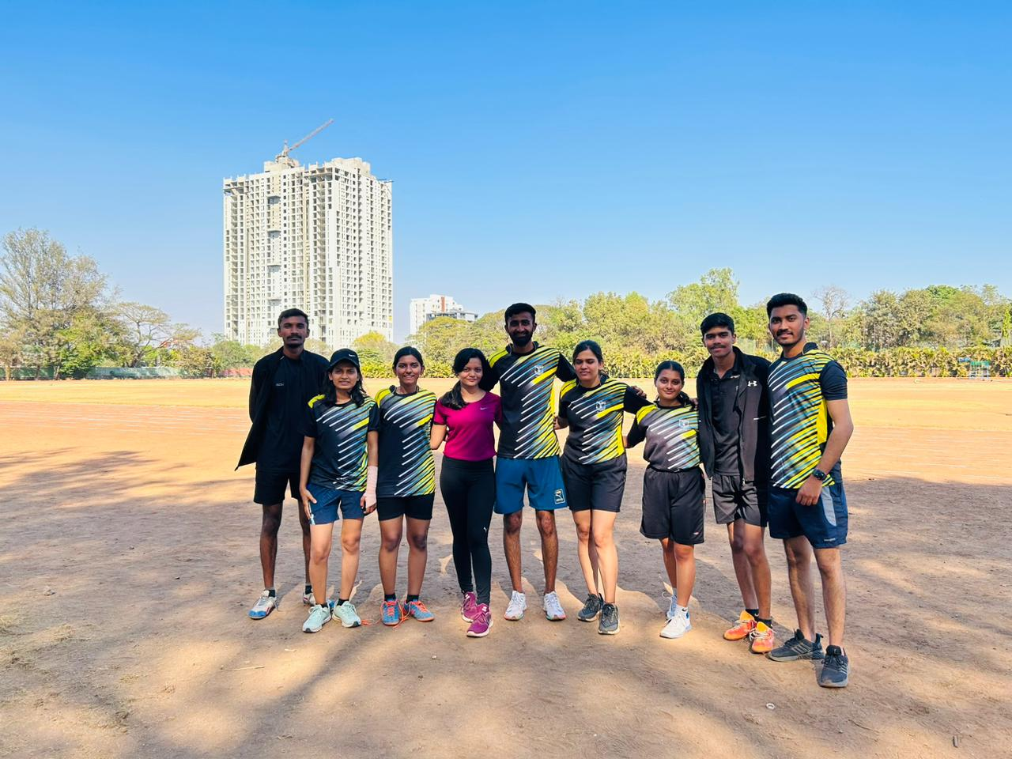
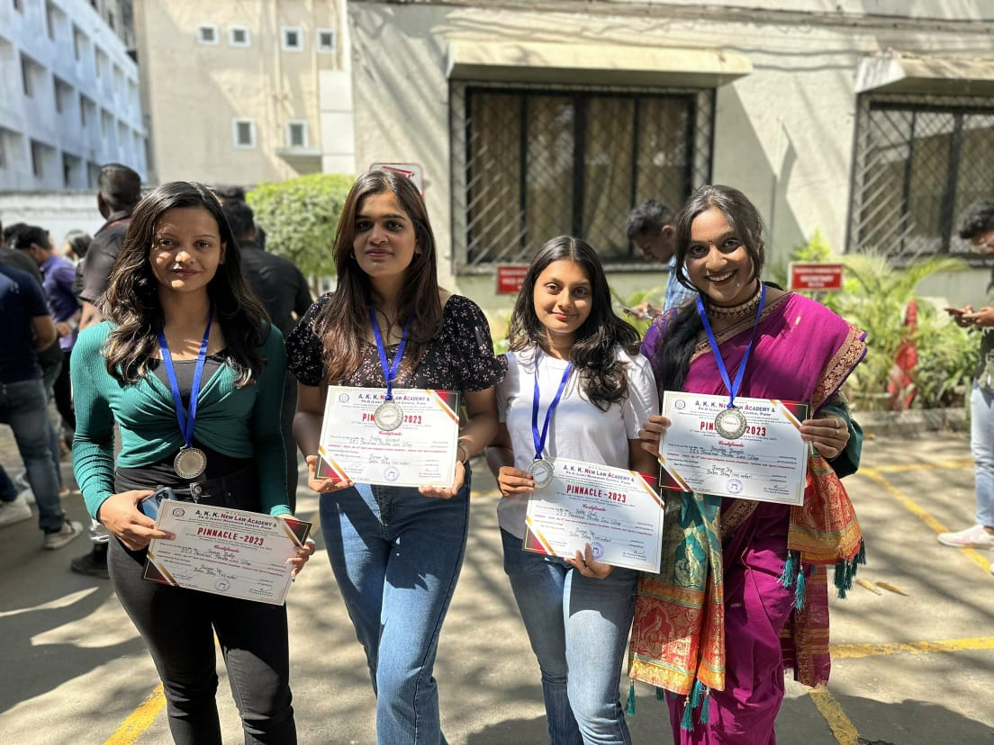
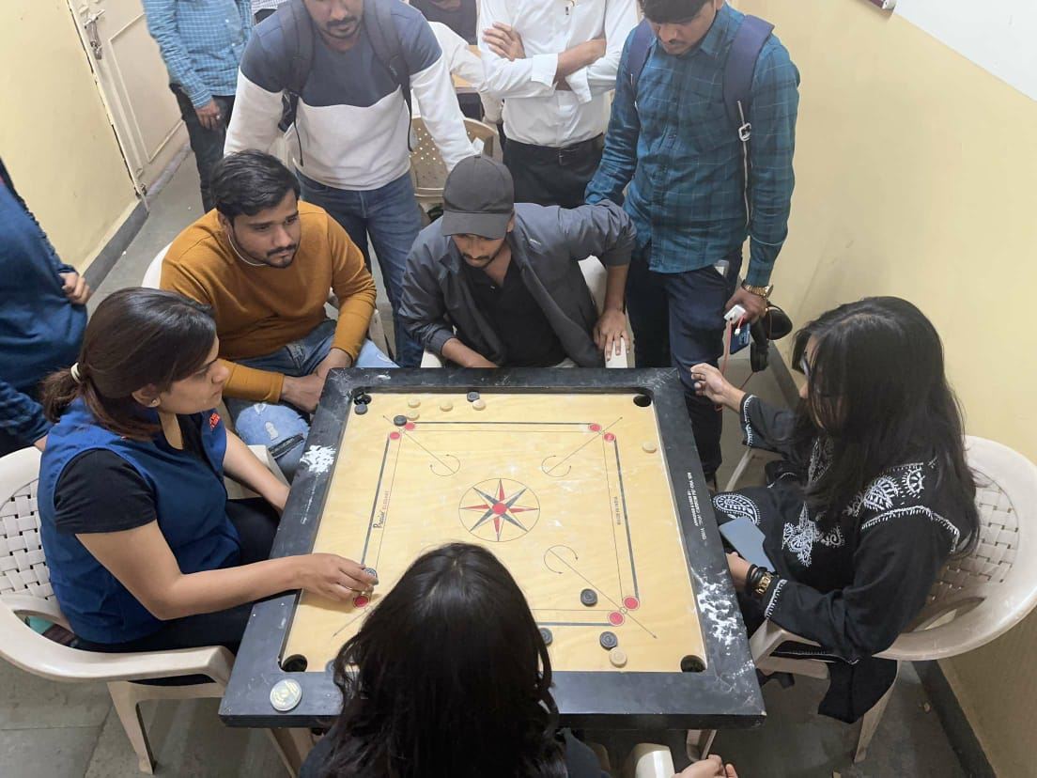
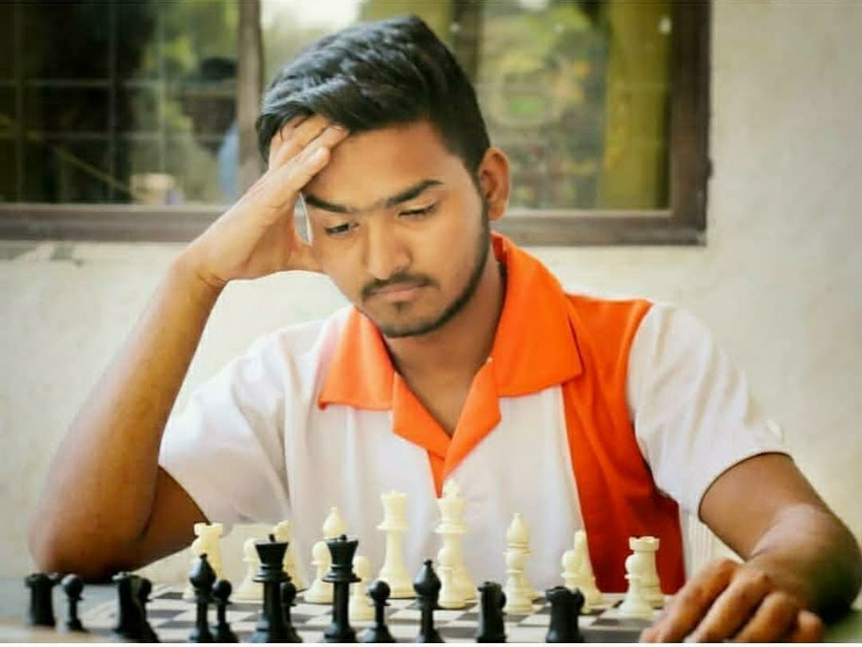
Here are a few moments of the event:
